**CS 628 Full-Stack Development II**

**HOS07B: Reverse Engineering Practice 4 for the Details Page**

July 19, 2020

12/29/2020 Updated by Min

School of Technology & Computing (STC)

City University of Seattle (CityU)

**Before You Start**

* The directory path shown in screenshots may be different from yours.
* Some steps are not explained in the tutorial**.** If you are not sure what to do:
  1. Consult the resources listed below.
  2. If you cannot solve the problem after a few tries, ask a TA for help.

**Resources**

* Holmes, S. & Harber, C. (2019). [Getting MEAN with Mongo, Express, Angular, and Node, Second Edition](https://login.proxy.cityu.edu/sso/skillport?context=148121). Manning Publications. (ISBN 9781617294754)
  + 4.5 Taking the Data out of the Views and Making Them Smarter
  + Appendix C: Dealing with All the Views
    - Listing C.1: locationInfo controller
    - Listing C.2: location-info.pug view template in app_server/views
* Pug, <https://pugjs.org/api/getting-started.html>

**Course Concepts**

* Understand the roles of Views and Controllers.
* Apply the process of taking the data out of the Views
* Make the Views smarter if necessary.

**Activities**

* Preparing for a MEAN project environment
* **Reverse Engineering the Details page**
* Source Code Management and Deployment

**Notice**  
**Since you have practiced HOS06A, B, & HOS07A, you will challenge HOS07B with minimal guidelines.**

**Preparing for a MEAN project environment**

1. Copy the “module07a” directory to the “module07b” one.
2. Open the “module07b” folder in the VSCode.  
   Close the “Welcome” window.  
   Open the terminal (Ctrl+`).
3. Test whether the application works correctly.  
   >>>npm start

|  |  |
| --- | --- |
| <http://localhost:3000> | <http://localhost:3000/about> |
| <http://localhost:3000/location/> | <http://localhost:3000/location/review/new> |

**Reverse Engineering the Details page**

1. Discover what data need to be moved to the about controller from <http://localhost:3000/location/>

You can find 3 areas for reengineering: A) Page header, B) Location, and C) Sidebar  
Area B needs more detail programming in Pug.

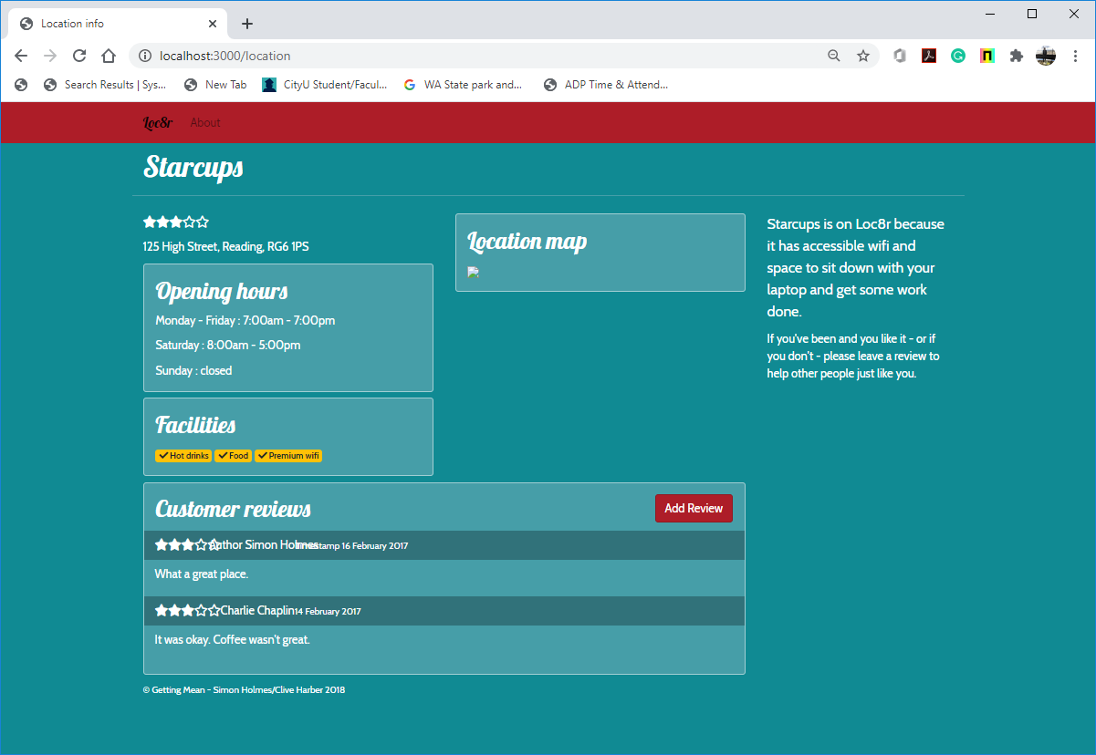

E)

F)

D)

C)

B)

A)

A)

1. You have six (6) areas for reengineering
2. Page Header & Sidebar
3. Rating and Address
4. Opening Hours
5. Facilities
6. Location Map
7. Customer reviews

Reengineer all sections by following the given steps below.

1. Look at the data in the view- location-info.pug
2. Create a structure for that data in the controller – locationInfo in locations.js
3. Replace the data in the view with references to the controller data - location-info.pug.
4. If necessary, look for opportunities to reuse code.

Notice:  
For your location map, use a free image address instead of using Google Map API.

1. Test whether the application works correctly.  
   >>>npm start

|  |  |
| --- | --- |
| Before | After |
| <http://localhost:3000/location/> | <http://localhost:3000/location/> |

**Source Code Management and Deployment**

**Push your work to GitHub**

Run the following commands to push your work to the GitHub repository:

Open the terminal from the VSCode by hitting the control + ~ key and type the following command:

>>> git add .

>>> git commit -m “Submission for HOS07B --yourname”

>>> git push origin master

**Push your work to Heroku**

>>> git push heroku master

If you cannot remember your branch name, run the command “git status” to check.